Minecraft Project

Crafter-Strike

5580968

Mahidol University International College

ICCS203 Computer ProgrammingII

Mr. Boonyanit Mathayomchan

Due Date: 2 March 2015

ShooterGame

(My Plugin name is “ShooterGame”)

Nowadays, Minecraft has an important role in the game society because there are a large number of player who play this game. Minecraft is the game that not focusing on beauty graphic at all, but it is a game that focusing on freestyle player. It means that the player can do anything in the game such as farm, mine, survival, and so on. The main purpose of Minecraft is that player has to survival in the land that do not have any people in the Minecraft world. It also provide player to play together, so that players can join together. In addition, player can also join other server to play and there are a lot of amazing thing in those server because they write a code to make their server more interesting. Like that server, i created Crafter-strike in my server to play with other people and i am so proud that i did it because in my opinion, this game is very amazing and interesting.

The planned features is that i will build a snake game because i am interested to build snake game that have an inspiration from snake game from Nokia. It is the first game that i played in my life, so i wanted to create snakegame in order to make a first game of my life.From the first time, i did not know much about the system, game, and all the plugin. I was very stress because i had no idea how to do it.

However, i changed my mind to do another game in this project, i changed to build the shootergame. ShooterGame is the game that inspire from the counter strike game, the game is about the terrorist and the cop that they have to do their mission to win the game. In addition, crafter-strike is not the same as counter stick because it combines between Country stick and Minecraft to make shootergame and it has a lot more interesting and more fun. Instead of using gun in counter strike, crafter strike uses only bow, arrow, and sword to kill another player, and also instead of playing only survival mode in Minecraft, the player can also play the crafter strike too. In shootergame, there are a lot of functions that make this game to be fun, such as, i set the damage of the lava, so that if anyone hit the lava, they will die. I can achieve to implement the shootergame and i am so proud to present this project. Furthermore, i will describe and explain all functions and how the game works in every detail in the next paragraph.

To begin with, the user have to run the command in code-2 file that is on the desktop, in terminal “cd desktop/code-s/shootergame” and “./build.sh”.

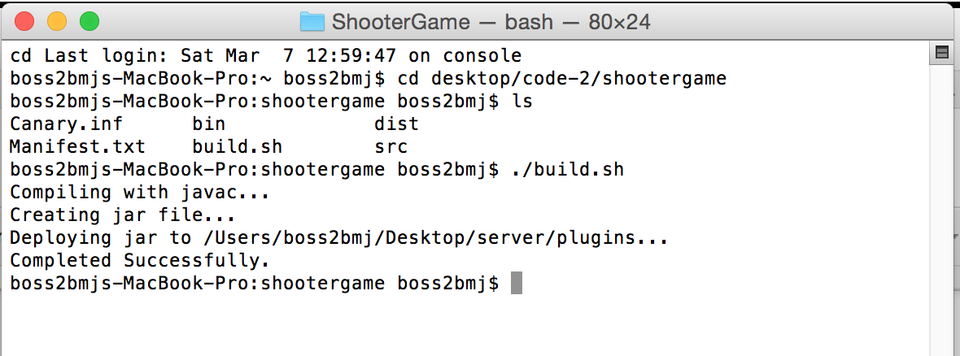

The user also have to run the server in the server file too in the terminal “cd desktop/server” and “./start_minecraft”, and then the user can open the game and play the game. 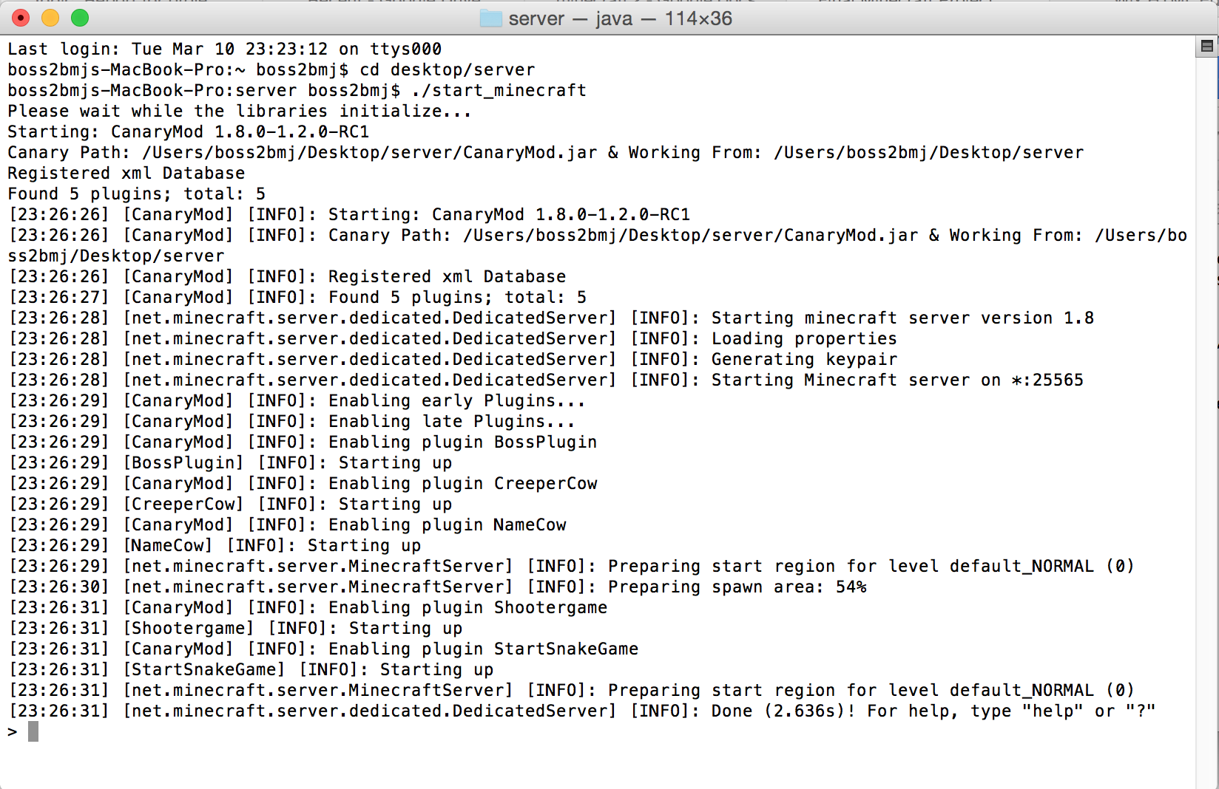

When the player connect to this server i set the connection hook that they will be spawned at the location that i set which is the start point that everyone will start in that place, the message of the introduction will show and i will give items which are a bow, two set of arrows, and one sword to all player. I give the maximum number of the arrow which is 64 arrows.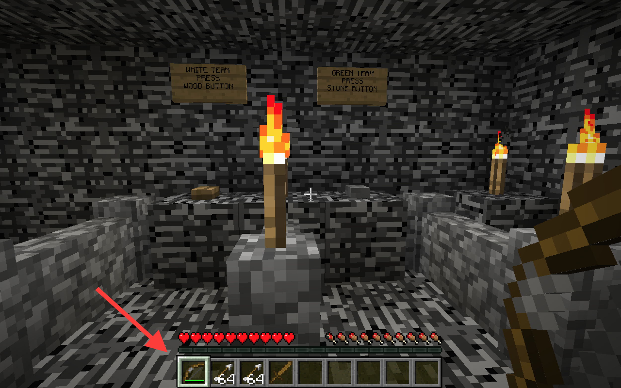

The next step is that the players have to choose the team by type “1” or “2”, and in this case i use onChat hook to make the player move to the teams that they choose by putting them into the list that i made. There are two teams that they can choose which is teaming one or team two.

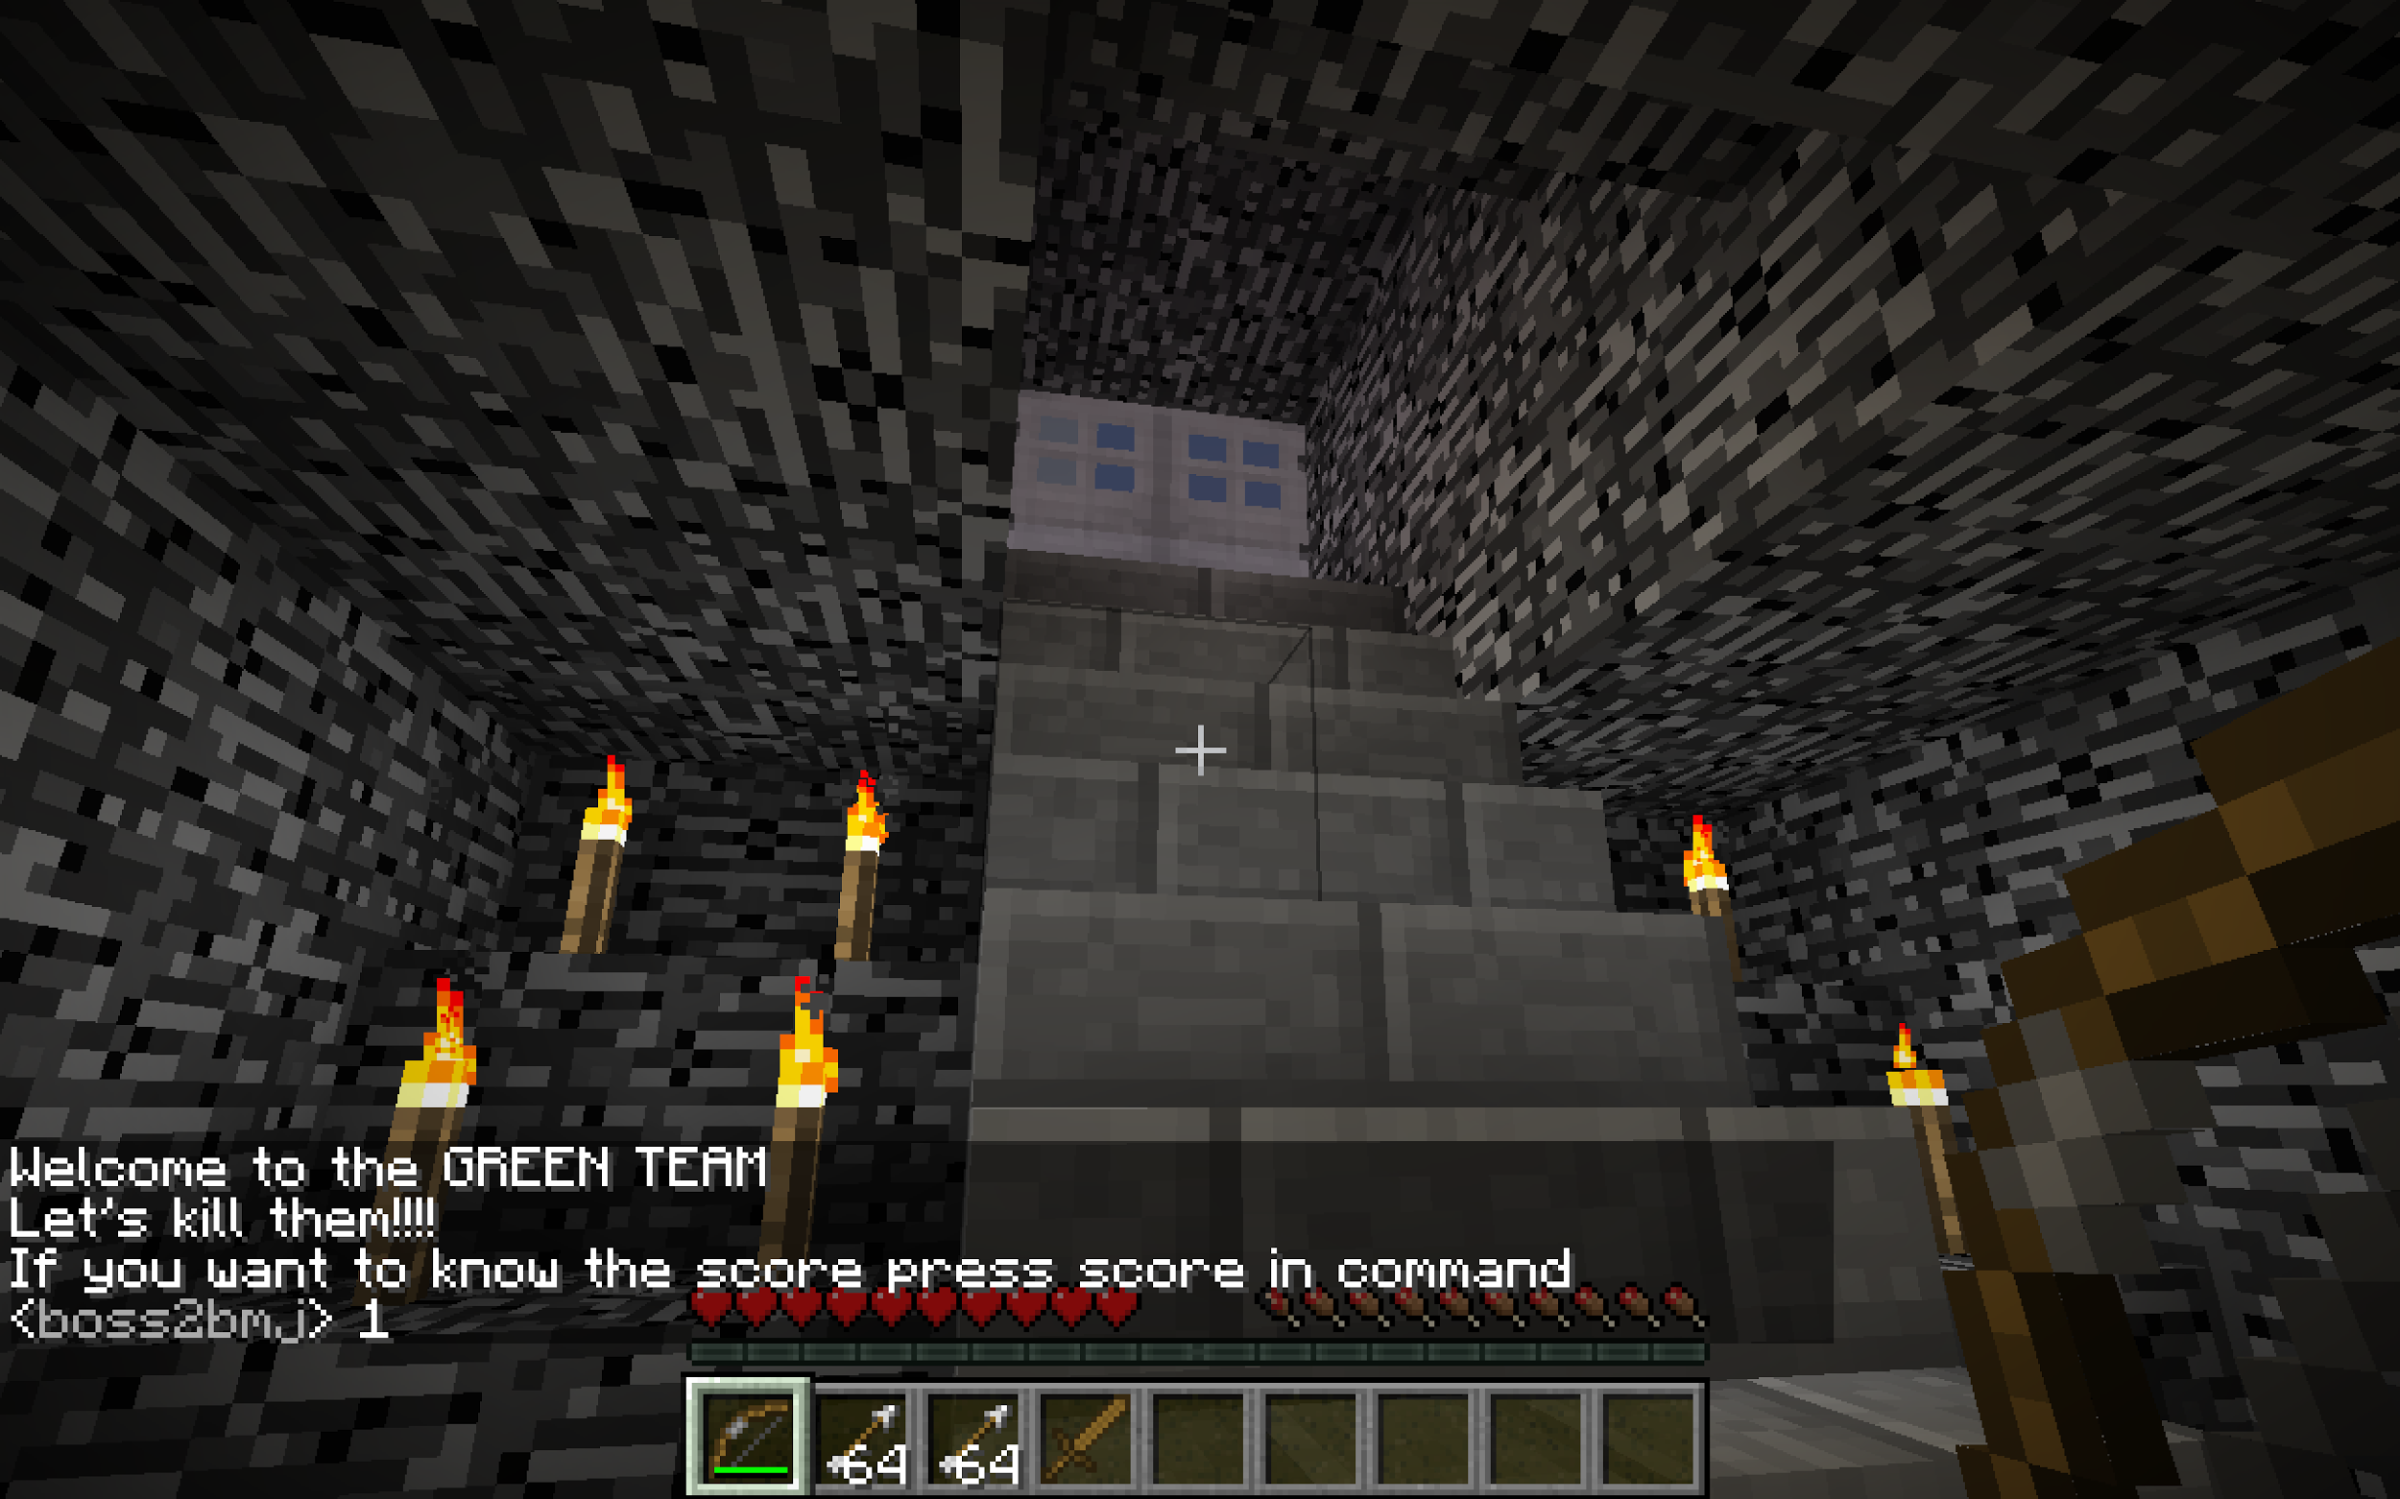

In addition, if players do not like to press a number, i have another option that they can choose the team which is clicking the button that is in the room. There are two buttons in the room, so player can choose teams. If the user choose team one, they will be spawned to the land of team one. Like team one, if the user choose team two, they will be spawned to the land of team two.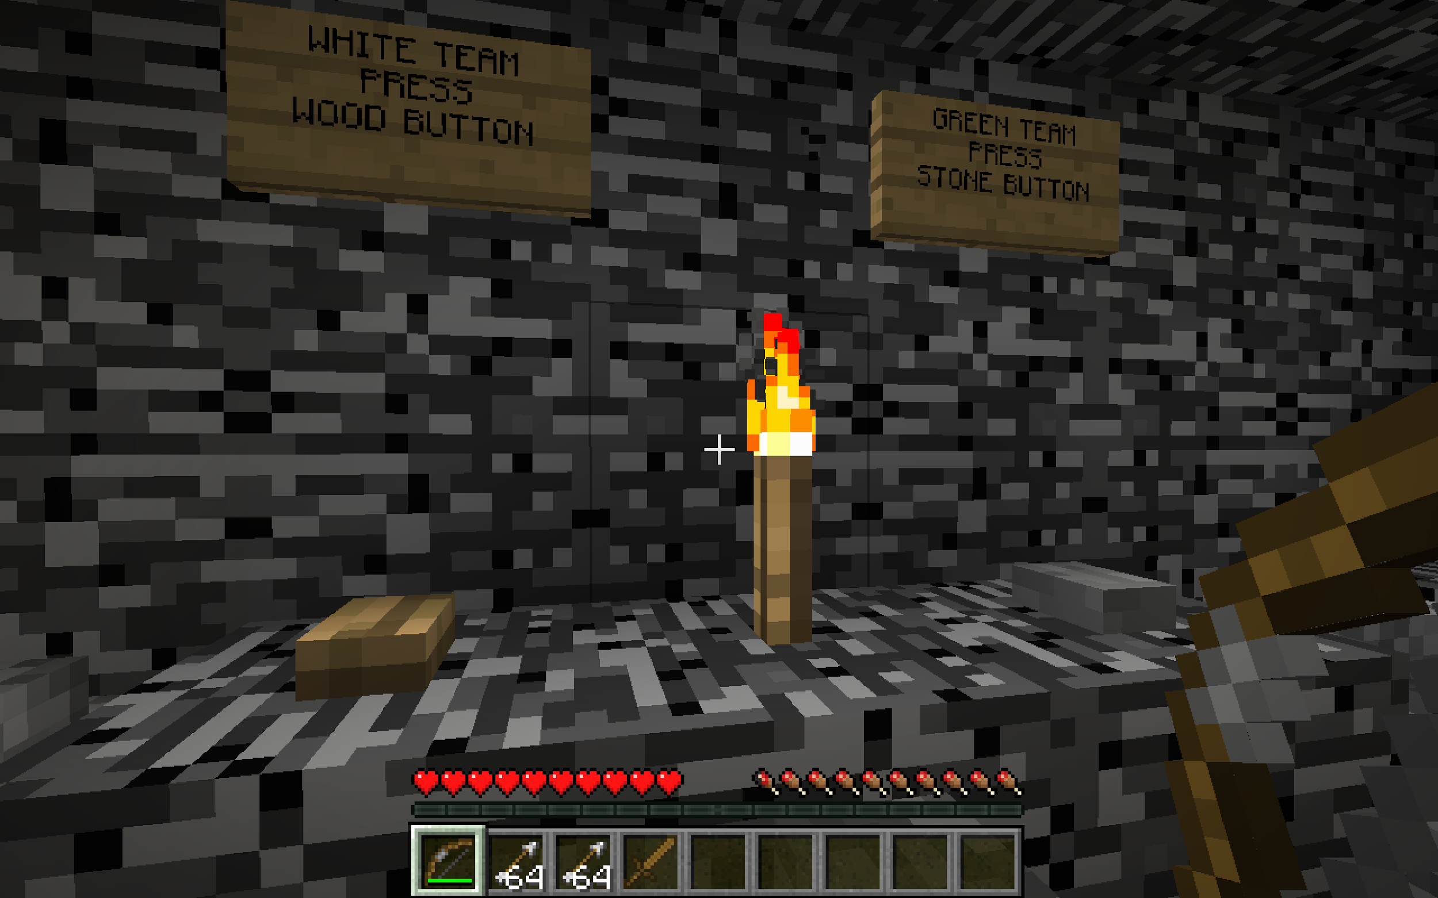

The most importance here is that before the player chooses the team i set the deleting player function before they choose the team. The reason that i set it before players assign to team because if the player want to change the team so the program will not confuse that there will be the same name in two teams. Another reason is that i have the score function that will score when the player die, so the program will know that which teams that will put a score on. In the score function, i use deathshook to count the score, if the player of team one die, team two will plus one point. However, if team two die, team one will plus one point.

After the player die, i use player respawned hook to set the spawn point of the player on team one and the player on team two, it means that if the player on team one die they will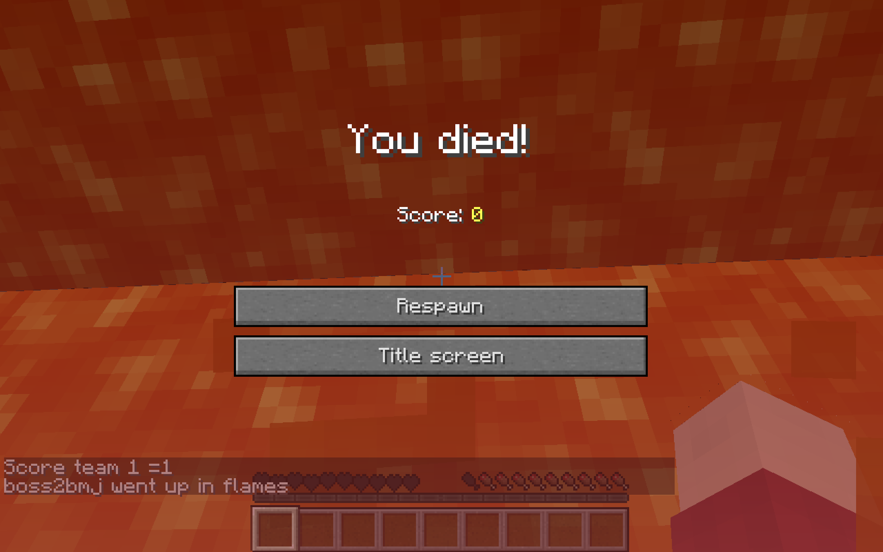 spawn at team one place and if the player on team two die, they will spawn on team two land. I also give the items to them after the death, so they can play the game again.

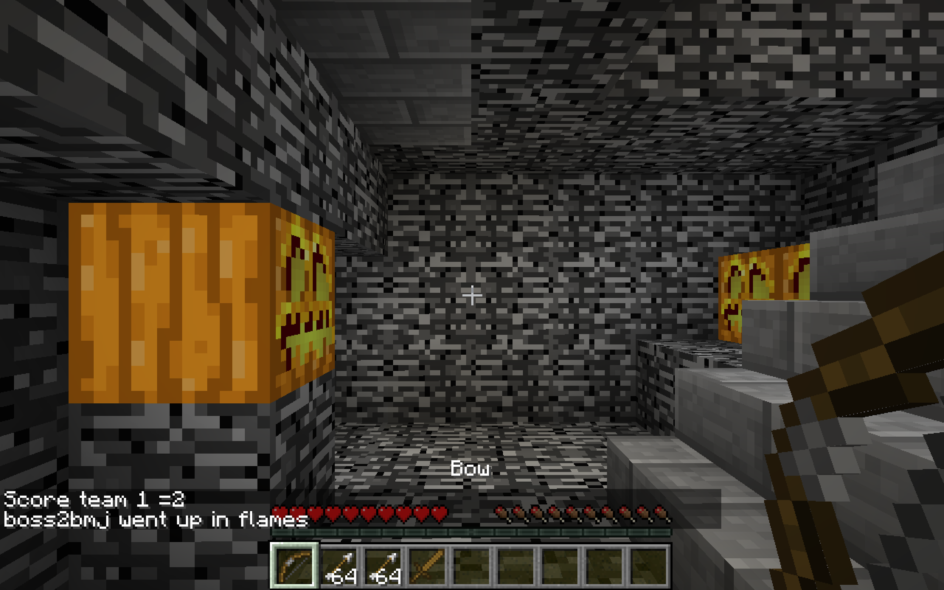

i use the projectile hit hook to set the damage of the arrow. It means that when players are hit from the arrow, they will immediately die. The reason is that i want to make the game more fun and challenge to the player. In addition, i use block right click hook to set the function warp to the player who right click on the box that i set. Not all the block that players can right click to warp, i set only special boxes. The reason that i use this is that i want the player to move to the top of the fortress, and also players can move down too.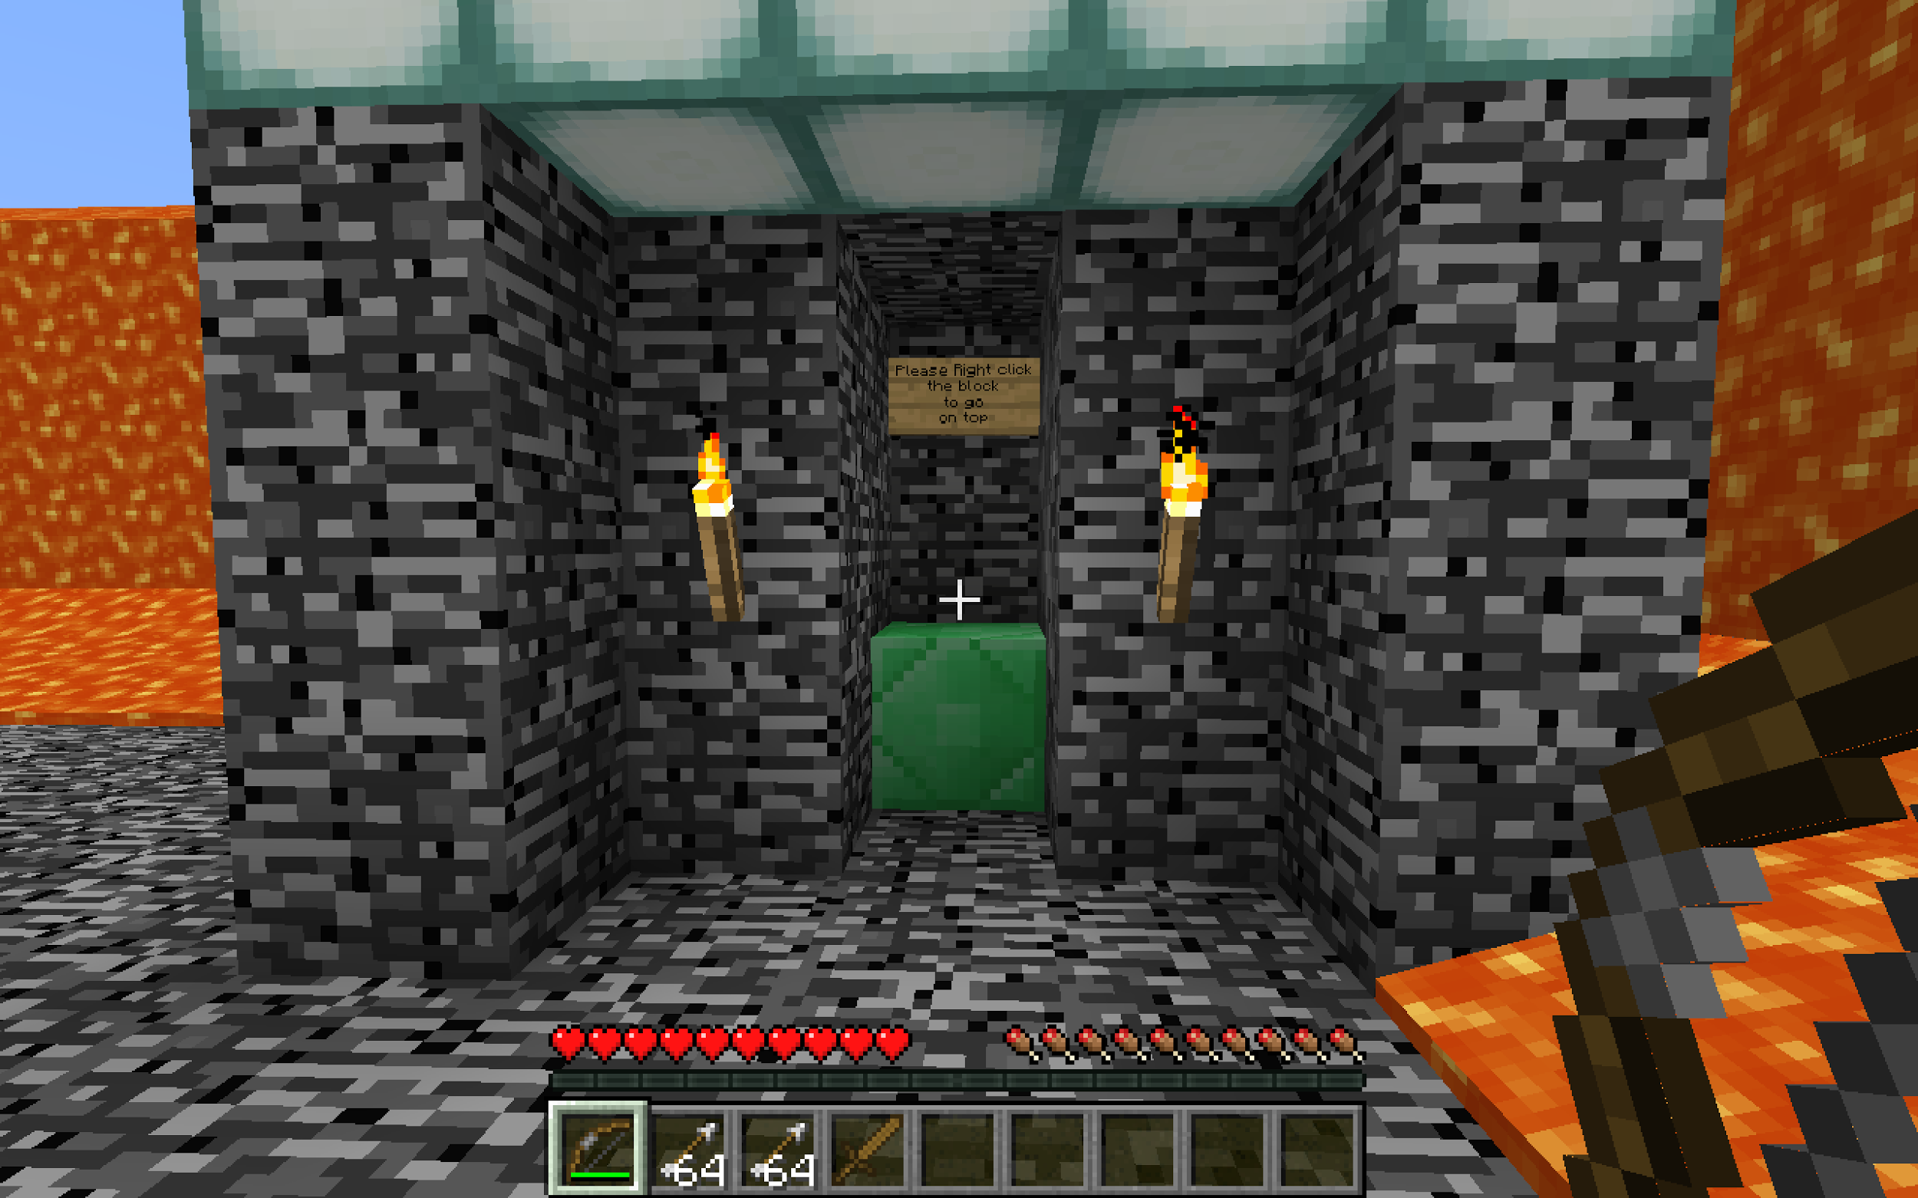

Click the box to move to the top of the fortress

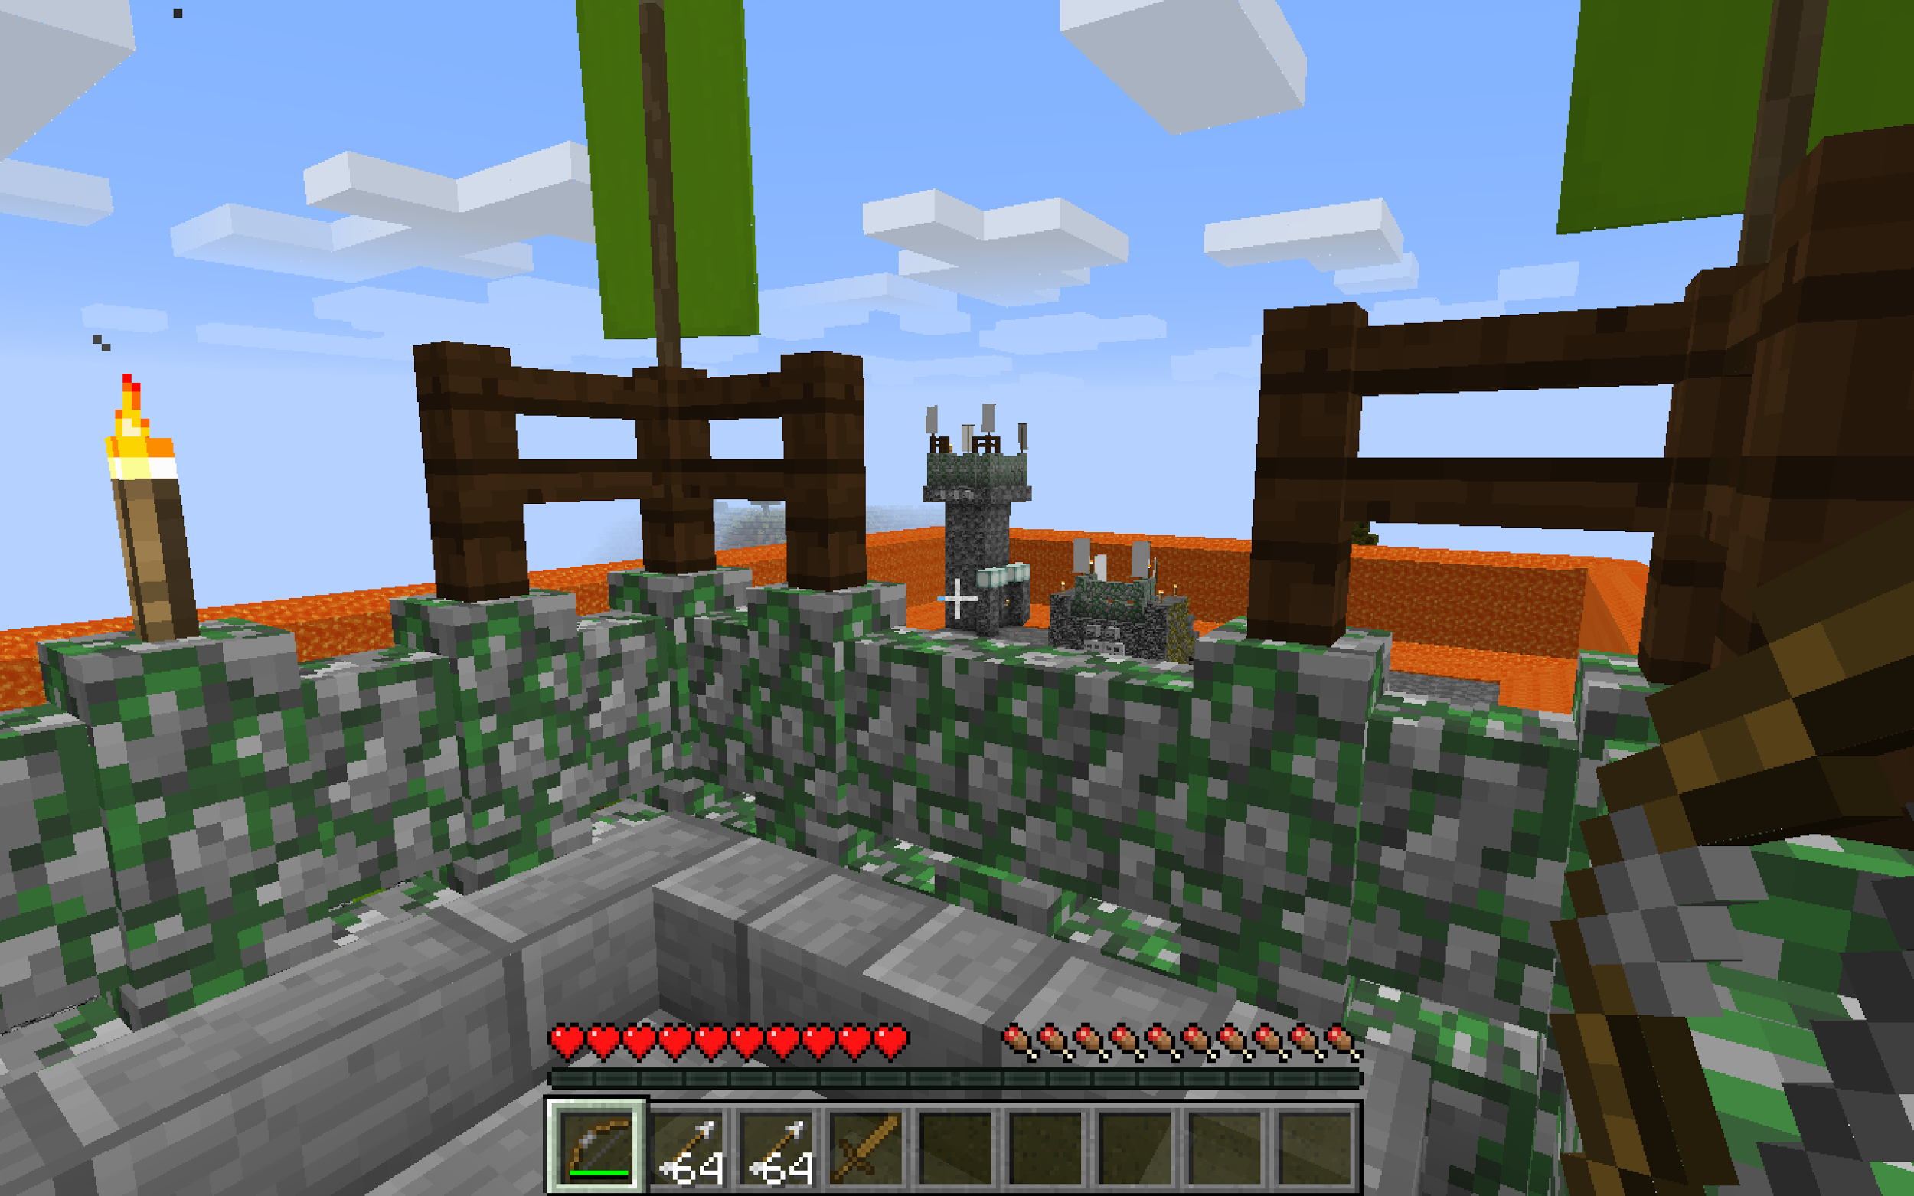

in the crafter-strike game, all player cannot destroy the block in the game if players want to destroy something they just left click to destroy, and here in my game they cannot do that because i use the left click hook to make all the player cannot destroy the block.

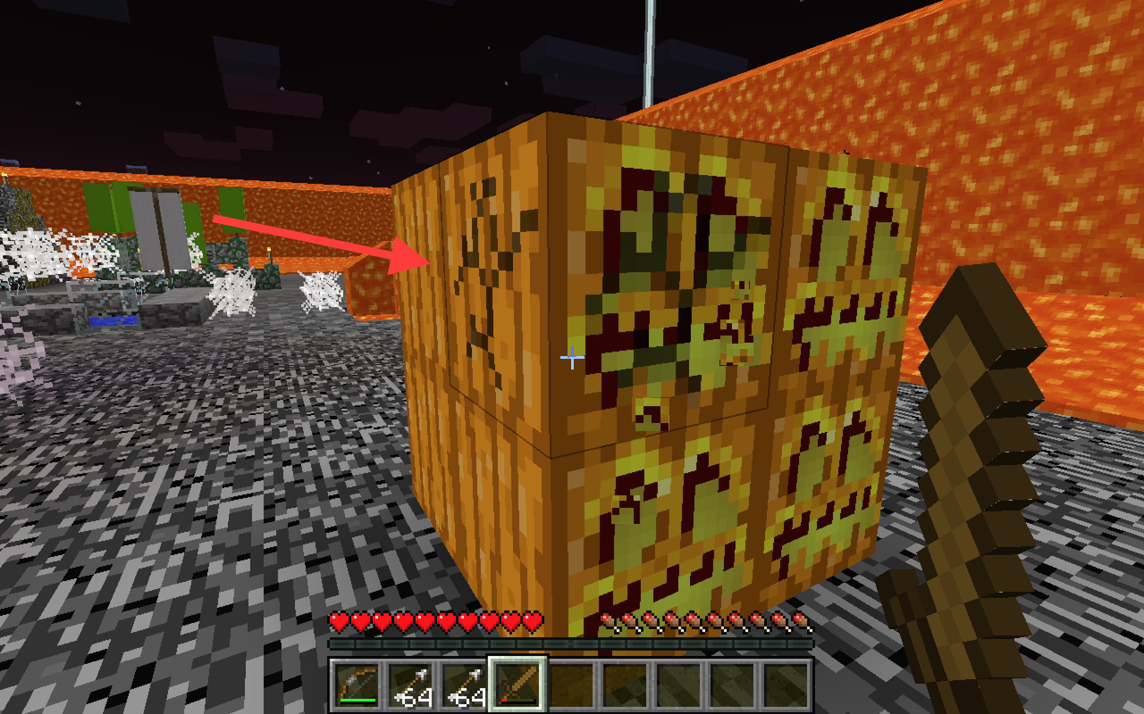

If the player touch or move on to the lava, they will die because i set the damage of lava, so that no one can go out of the game by running through the lava. It also makes the game to be more challenge.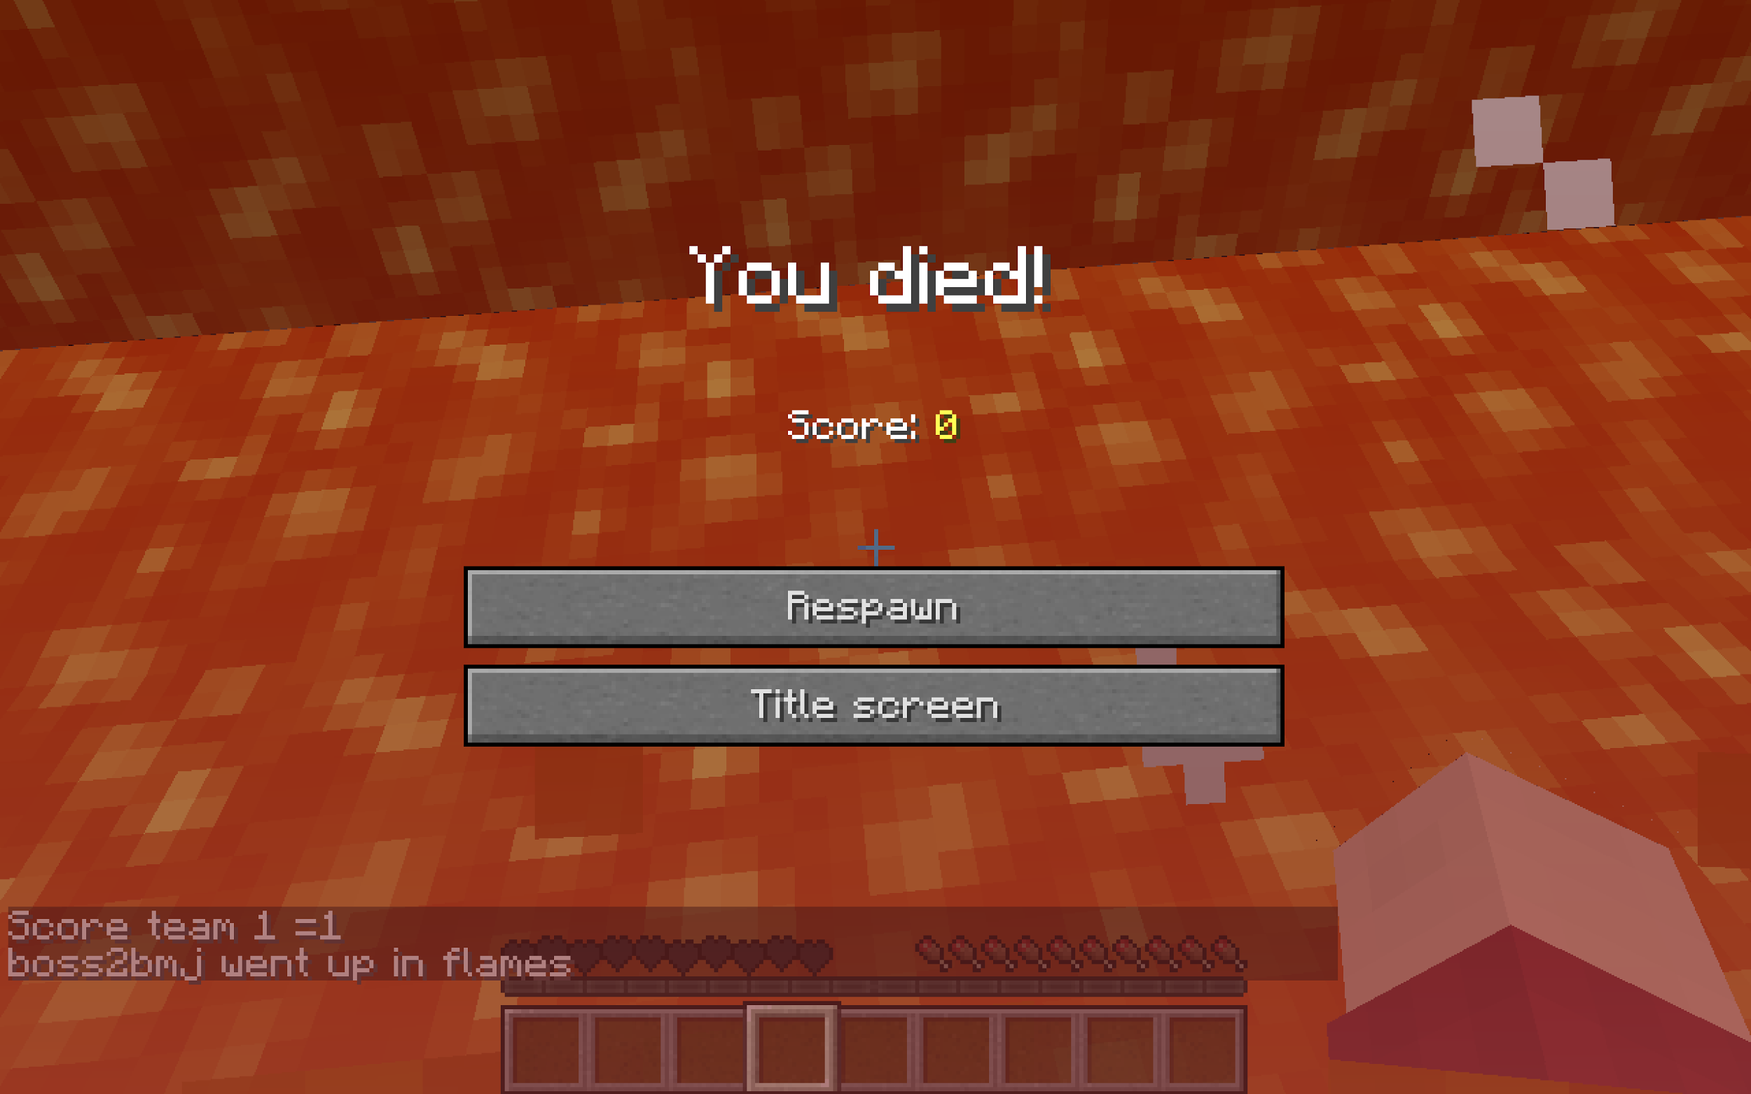

Furthermore, there are a lot of commands that you can type during the game. To start with, “/quitgame” command if players type that in command, they will quit the game, game here means crafter-strike game, and move to the first place that they connect. If they want to play again just press “1” or “2” or just click buttons in the room, otherwise you will stay in that room forever.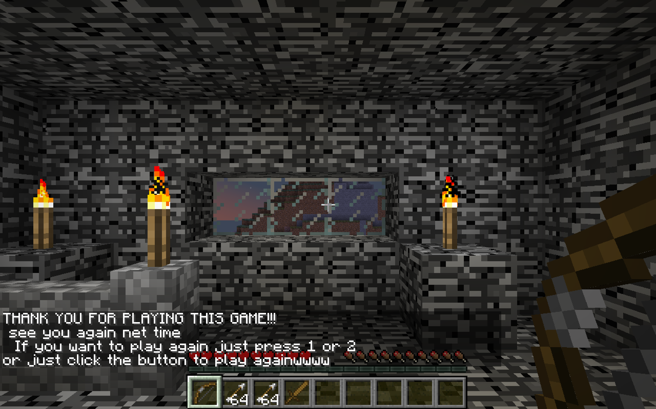

The this play will show Thank you to the player.

Next, if the player type“/score”, the score will show on the message, and you can see the score of the both teams for example, scoreteam 1 = 5.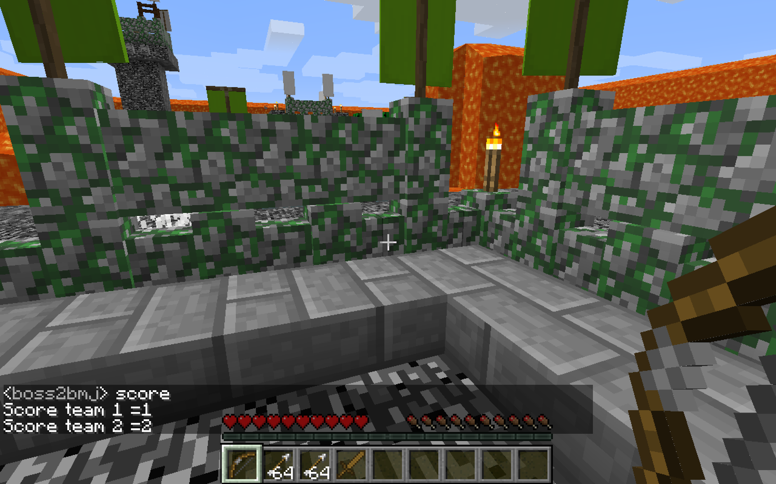

Last, the command “/reset” in case of players want to reset the score, so this command will delete all the score and set it to be zero.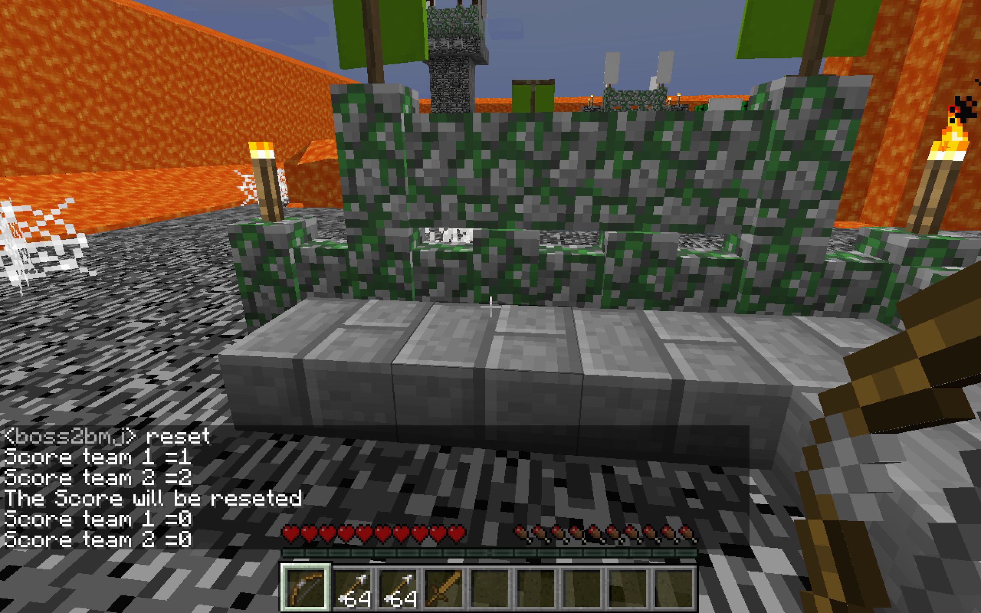

In This system contain eight hook that i use from APIs, and i will explain it all here.

1.) “ConnectionHook”.

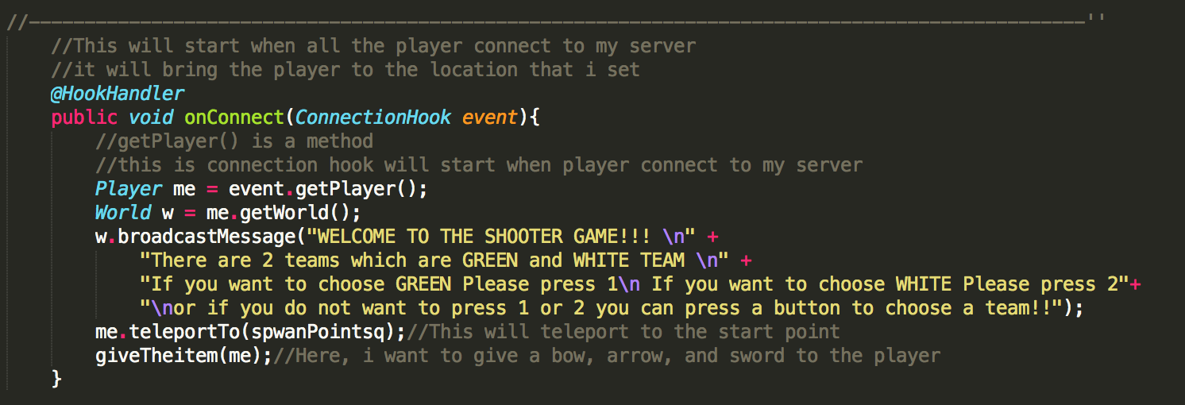

I use This hook because i want the player who connect to my world that will spwan point to the location that i set to. In order to use this hook, the player have to connect into my game

2.) “ChatHook”

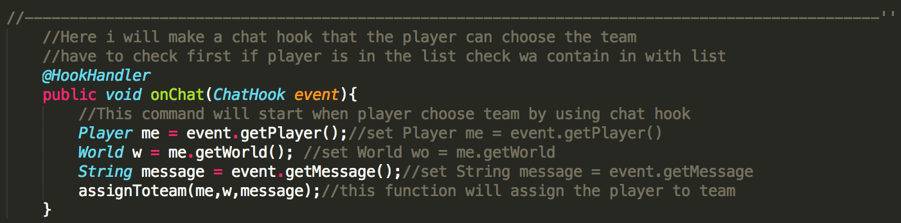

I use “ChatHook” because i want the user to type 1,2 to assign them into the team so they have to choose which that they want to be. In order to use this hook, the player have to press 1 or 2 in the chat, and you can use it anytime and anywhere that you want to change a team.

3.) “ProjectileHitHook”

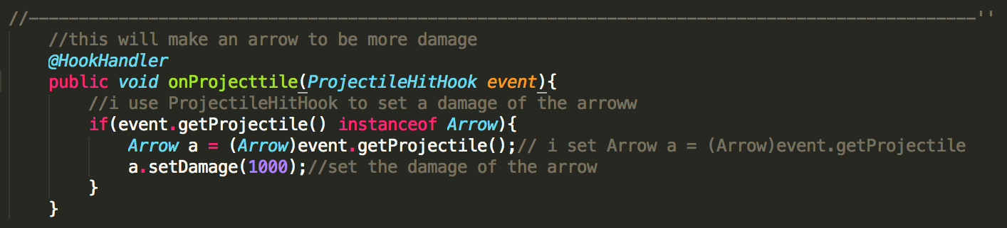

In order to use this hook, the player have to use the arrow to attack the other player and they will die if they hit by the bow because i use this hook to set the damage of the arrow. The user can use it anywhere in the game or when you want to attack other people.

4.) “PlayerDeathHook”

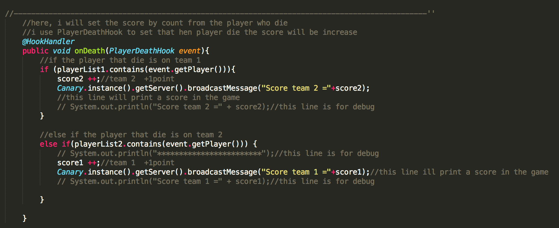

In order to use this hook, the player have to die first, and it will add score to different team. I use it because i want to make the score for this game, so the player will enjoy more because they have competition with other.

5.) “PlayerRespawnedHook”

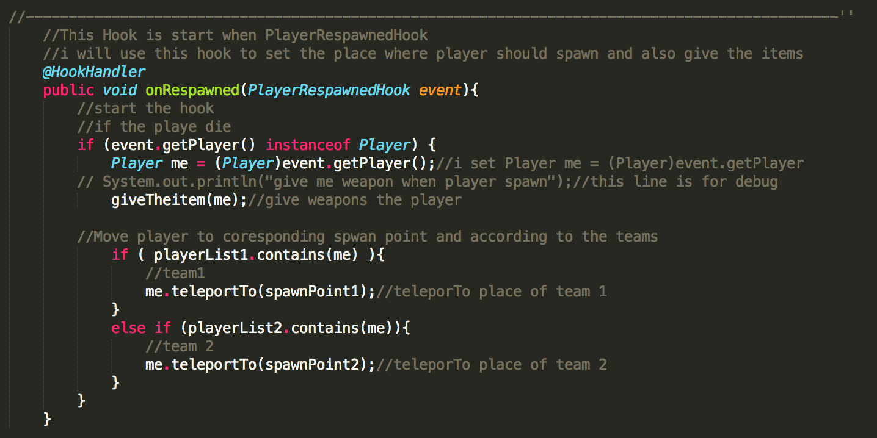

In order to use this hook, it will respwaned the player when they die to the location of their team. Here, it means that if you choose team 1, it will spawned to one place. However, if you choose team 2, it will spawned to another place.

6.) “BlockRightClickHook”

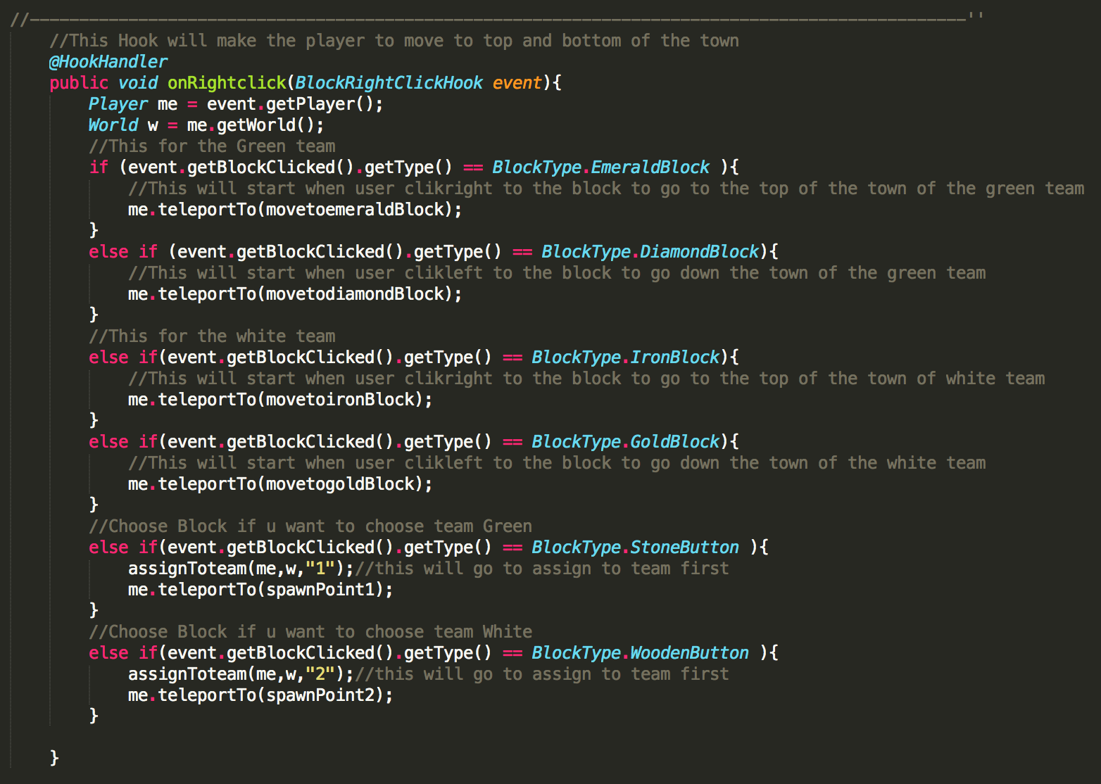

In order to use this hook, the player have to right click to the special box that i set in to the map, so it will teleport to the location that i set from the different box.

7.) “BlockLeftClickHook”

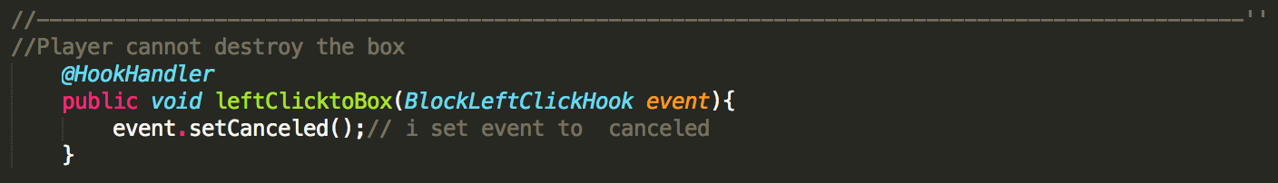

In order to use this hook, the player have to left click to the box(All box), and the box will not destroy. I use this hook because i do not want the player to destroy my map because if i let them to destroy my map, so the map will not beautiful.

8.) “DamageHook”

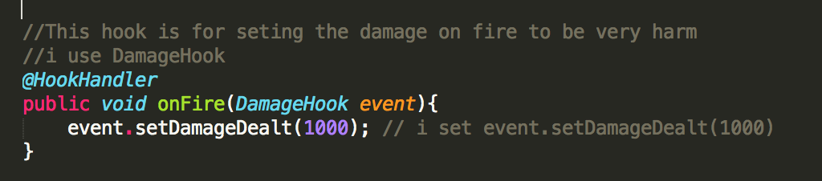

I use this hook because i want to set the damage of the lava, so when the player get on fire, they will immediately die. In order to use this hook, the player have to jump into the lava or get the lava damage.

The Problem that i encounter is that for the first time i do not know how to use all the APIs, and it made me very hard to do it, but i spend a lot of time to study about the APIs, and it does not hard than i expected. In contrast, i can build the game anywhere and i am so proud of it. Another problem is that sometime i use the wrong hook and it makes me very confuse to debug it. Finally, the big problem that i have to face is that how to assign the player to different team. Here it means that if i cannot divide the player into two team, this game will not be the competition game, and the system will do not know which team that it should assign the score to, so this the big problem that i face too.

The most proud features of my game is that i can build the game that i love to play as “Counter-Strick”. It is the game that divided player into two teams and correct the score by killing the player that differ to their team. This game has a lot of functions and hook to make this game more amazing and challenge to the user. The user can also type a command to see score, quite a game, and reset the score.This game is a combination between minecraft and counter strike, so i believe that this game will make you feel fun to play and if you play with your friend, it will be the best game ever. Last but not least, minecraft is the game that has a large number of the user all around the world, i think that if i continue to develop this game and open it to worldwide, i believe that there will be a large number of people will play my game.

The features that i plan to add is that when the user use /resets command, i want to fix that only the host can do it not everyone. I think that this command should not provide to everyone to do it because the player will use this command very often. I really want to make a scoreboard to display the score instead of typing “/score” score command, so the player can easily to see the score. Lastly, i want to make the game that the player that are in the same team can not attack to each other, or it might be optional for the player to choose that the player that are in the same team can attack or not.

Lastly, This is a hardest question that i have to answer is that “How would you rate your project(out of 10)?”. I would rate my project 9 out of 10 because i spent a lot of time to learn all APIs and build this amazing game that i am so proud of it. In addition, i code this game about 300 lines and use 8 hook to build my game, so i think that i should get 9 out of 10.